Activity 02  | P1 | P2 | P3 | P4 | P5 | P6

# **Activity 02:**

**Selection**

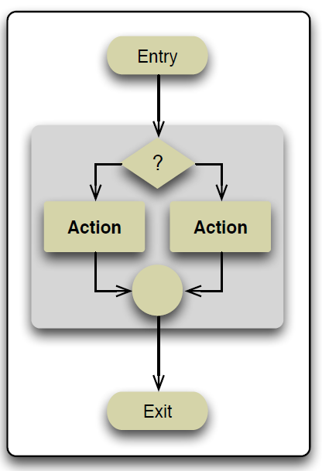

**Explore Selection** using   
decision scenarios using,

**Selection or** *decision construct* the programtakes a

**courses of action**, depending on the answer, after which the program moves on to the next Action in the Sequence.

**Selection**

Use your school **OneDrive** store your Digital Solutions work.  
Naming Convention required = **DS_Surname_FirstName_ID**

**Eg DS_Mathews_Mike_0123456**

Save this file to that Folder as **“Activity02.docx”**

Note: you will also save the python files (x6)

eg **Act02_proj1**.py ( + Act02_proj2….…proj6 )

Activity 02  | P1 | P2 | P3 | P4 | P5 | P6

# **Project 1**

Write a new Python program that prompts the user for 3 marks ( 1..100), The program will need to find the average of the marks and Test to see if the average is a Pass or Fail **The pass mark is set as >= 65%**

|  |
| --- |
| Enter your first mark between (1and 100): 10  Enter your second mark between (1and 100): 2  Enter your third mark between (1and 100): 4  The average of these marks is: 16  Congratulations on your PASS or  Sorry Not Satisfactory |

Sample **output** should

look like this

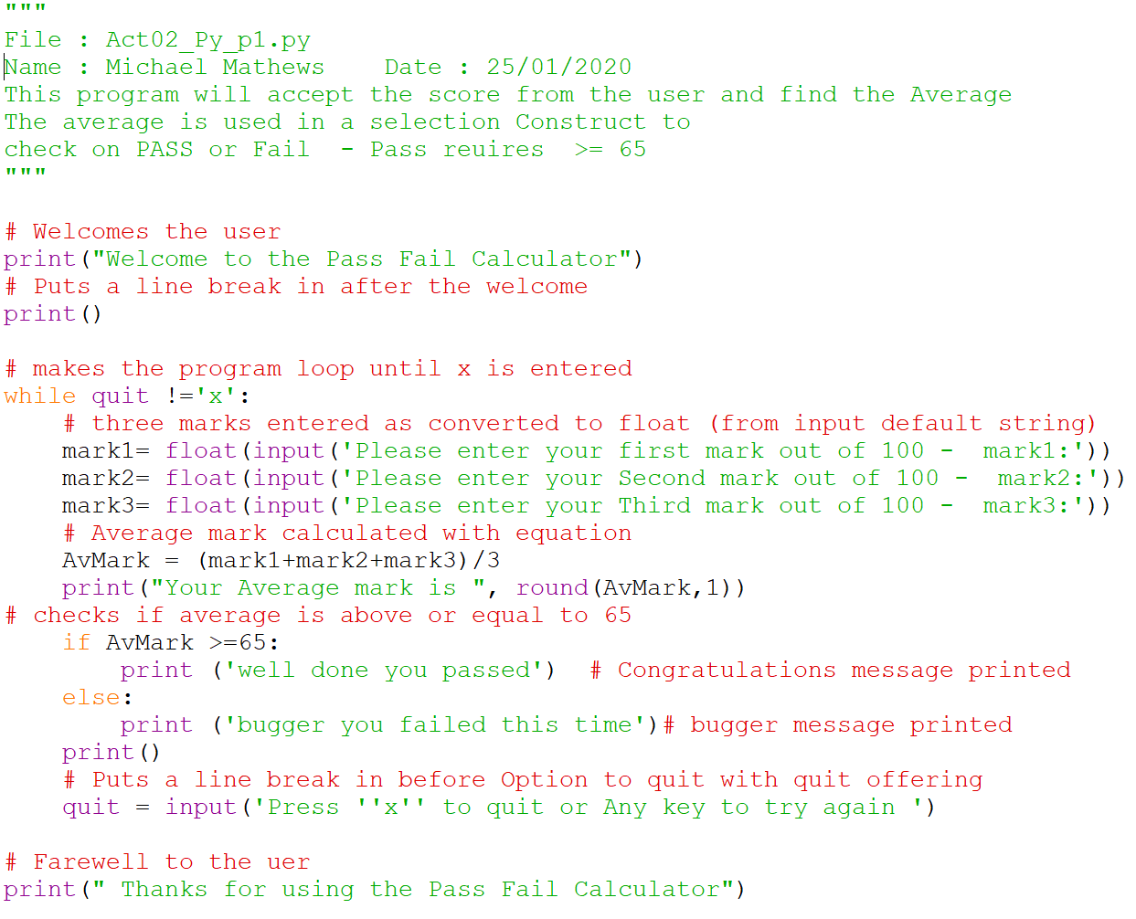

Activity 02  | P1 | P2 | P3 | P4 | P5 | P6

# **Project 2**

Write a new Python program that prompts the user for four test results.

|  |  |
| --- | --- |
| Grade | Required Mark |
| A | >=90 |
| B | >=80 |
| C | >=60 |
| D | >=50 |
| E | <50 |

Use the students **average mark**

to determine the final grade

using the following

grade cut-offs

|  |
| --- |
| **Enter Test Result 1 :**  **Enter Test Result 2 :**  **Enter Test Result 3 :**  **Enter Test Result 4 :**  **Average Mark is …….**  **Overall Grade is ……** |

Sample **output** should   
look like this:

**BEGIN**

Enter Mark 1

Enter Mark 2

Enter Mark 3

Enter Mark 4

Average = (Mark 1 + Mark 2 + Mark 3 + Mark 4 ) /4

**IF** Average >=90

Grade = A

**ELIF** Average >=80

Grade = B

**ELIF** Average >=60

Grade = C

**ELIF** Average >=50

Grade = D

**ELSE**

Grade = E

Print Average and Grade

**END**

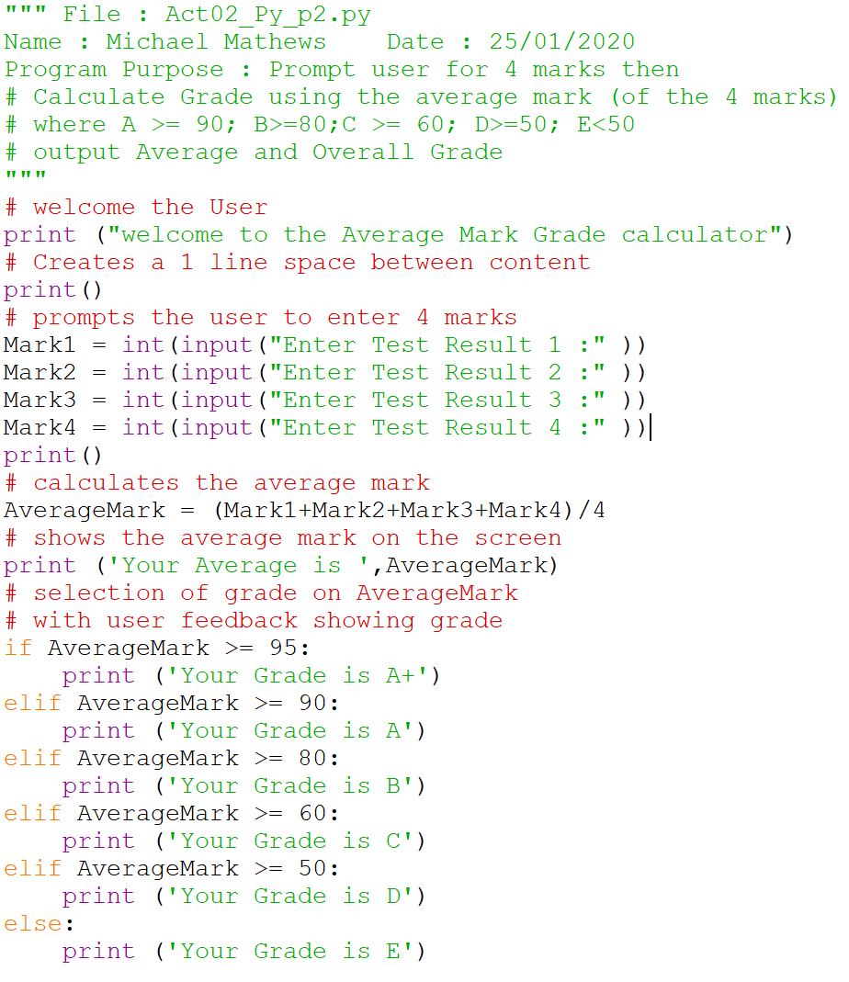

Activity 02  | P1 | P2 | P3 | P4 | P5 | P6

# **Project 3**

Write a Python program that simulates the rolling of a two die.

The user can keep on rolling the two dice and see

The roll number and The Dice totals until they press x to quit

Sample **output** should

look like this:

|  |
| --- |
| Roll Number:  Total on Die1 is :  Total on Die2 is :  Roll number _ had a total value of _  Rolling a _ makes you a winner  **OR**  Sorry you loose  Roll again or Press x |

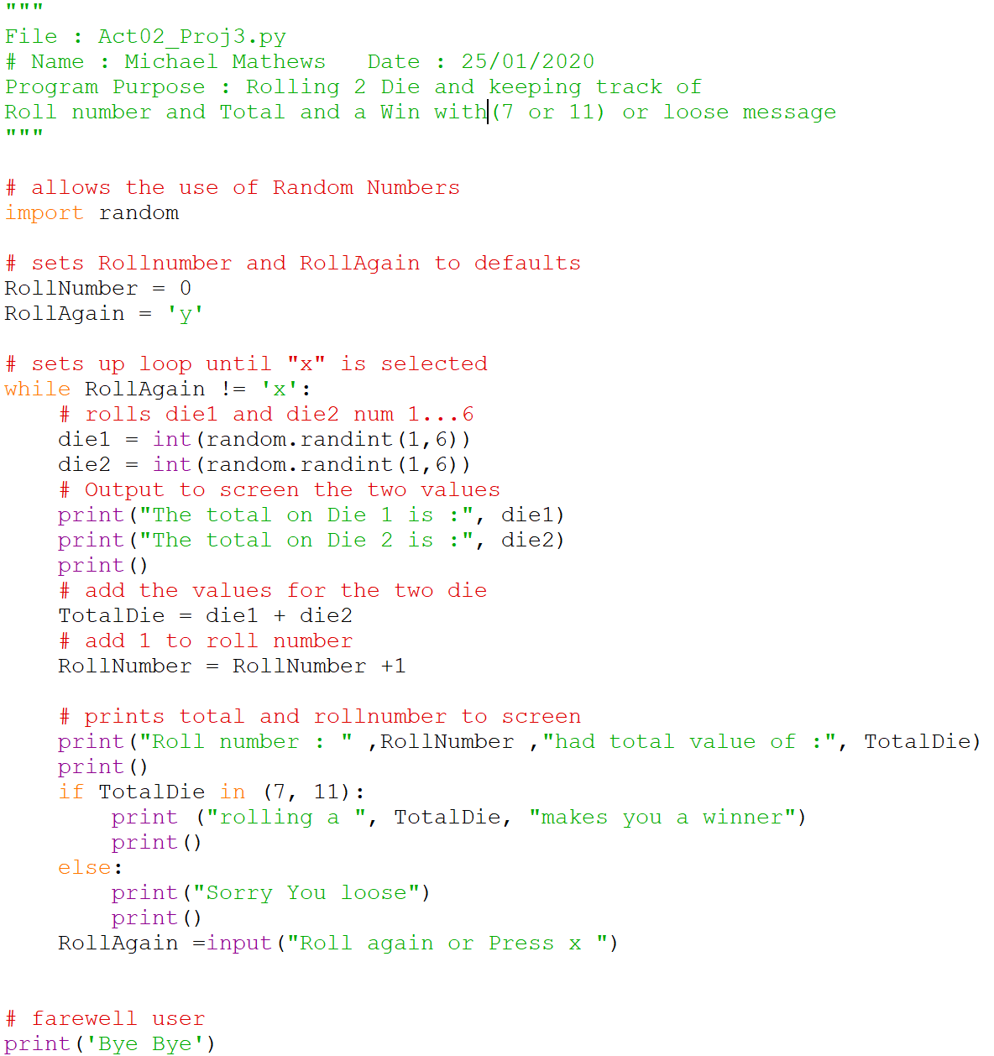

Activity 02  | P1 | P2 | P3 | P4 | P5 | P6

# **Project 4**

Write a new Python program that rolls a simulated die 100 times

Tally and Output the total **Occurrence of each Die Value**

|  |
| --- |
| Welcome to the die roll simulation  After 100 Rolls  Total Rolls for One is :  Total Rolls for Two is :  Total Rolls for Three is :  Total Rolls for Four is :  Total Rolls for Five is :  Total Rolls for Six is : |

Sample **output** should

look like this:

**Note the use of the loop for 100 rolls**

for i in range(100):

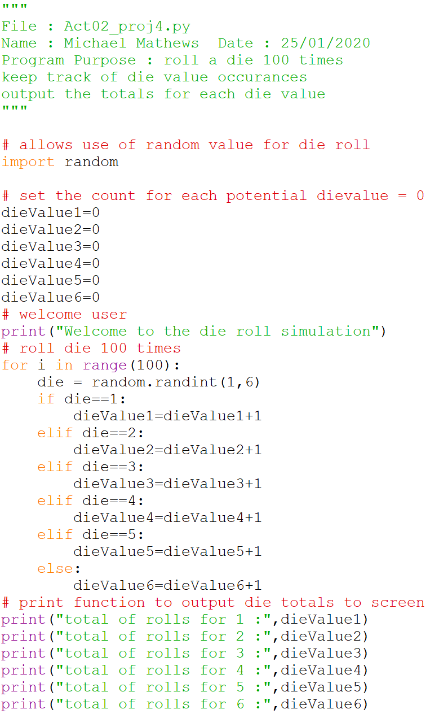

Activity 02  | P1 | P2 | P3 | P4 | P5 | P6

# **Project 5**

|  |
| --- |
| Total  Total of Two occurrence was :  Total of Three occurrence was :  Total of Four occurrence was :  Total of Five occurrence was :  Total of Six occurrence was :  Total of Seven occurrence was :  Total of Eight occurrence was :  Total of Nine occurrence was :  Total of Ten occurrence was :  Total of Eleven occurrence was :  Total of Twelve occurrence was : |

Write a new Python program that simulates rolling **two dice** and

records the sum of their totals for 100 rolls. Tally and Outputeach total Die Value **and the total Occurrence**

**BEGIN**

Reset dieTotal(2) ..(12) to 0

**FOR** 1 to 1000

Roll Die

Die1 = Random 1 to 6

Die2 = Random 1 to 6

**diceValue** = Die1 + Die2

**IF** **diceValue** = 2

dieTotal2 = dieTotal2 + 1

**IF** **diceValue** = 3

dieTotal3 = dieTotal3 + 1

**IF** **diceValue** = 4

diceTotal4 = dieTotal4 + 1

……

**IF** **diceValue** = 12

dieTotal12 = dieTotal12 + 1

print dieTotal2

print dieTotal3

print dieTotal4 ………. print dieTotal11

print dieTotal12

**END**

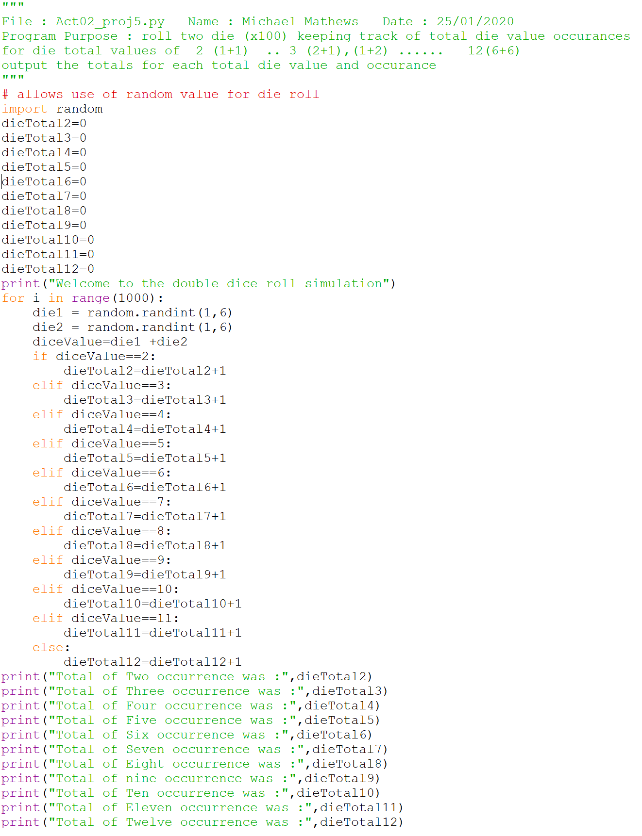

Activity 02  | P1 | P2 | P3 | P4 | P5 | P6

# **Project 6**

Write a new Python

program that rolls

three simulated dice

looking to be

**a BIG Winner**

by rolling

**Three of a Kind**

or small **Winner**

by rolling **1 Pair**

Note

**AND**

**is inclusive and**

**Requires Both**

**OR**

**requires any**

**either will do**

